

PRAYERS

AT THE CLOSE

OF LIFE

Some suggestions to help you

Photo copyright Jane LLoyd

**Why we have written this leaflet for you**

As you know, we are in the middle of the Covid19 epidemic and the resources of the hospital are extremely stretched.

If you have been offered this leaflet, it is because, sadly, the hospital’s chaplaincy team is currently unable to pray with you in person.

# The aim of this leaflet is to provide you with some resources to use with your loved one.

Photo copyright Nigel LLoyd

**The Lord’s Prayer (traditional)**

*As Jesus taught us, so we pray…*

**Our Father,**

**Who art in Heaven,**

**Hallowed be thy name.**

**Thy Kingdom come, thy will be done**

**On earth, as it is in heaven.**

**Give us this day our daily bread,**

**And forgive us our trespasses,**

**As we forgive those who trespass against us,**

**And lead is not into temptation,**

**But deliver us from evil:**

**For thine is the kingdom,**

**The power and the glory,**

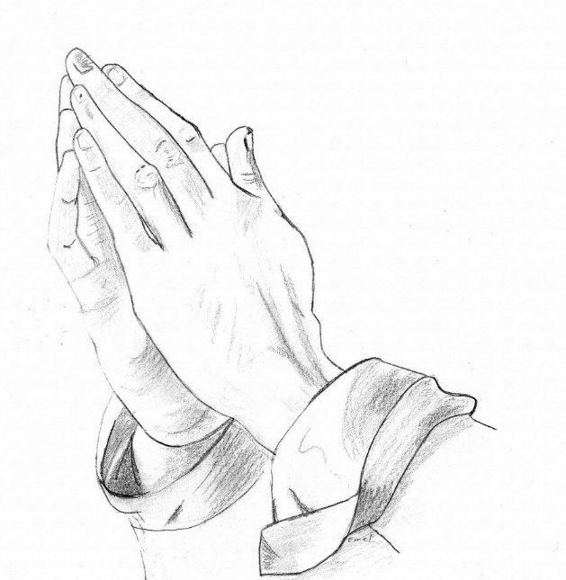**For ever and ever**,

**Amen. Psalm 23**

## **The Lord is my Shepherd: Therefore can I lack nothing.**

**He shall feed me in a green pasture:**

**And lead me forth beside the waters of comfort.**

**He shall convert my soul: and bring me forth in the paths of righteousness, for his Name’s sake.**

**Yea, though I walk through the valley of the shadow of death**

**I will fear no evil: for thou are with me; thy rod and thy staff comfort me.**

**Thou shalt prepare a table before me against them that trouble me: thou has anointed my head with oil, and my cup shall be full.**

**But thy loving kindness and mercy shall follow me all the days of my life:**

**And I will dwell in the house of the Lord for ever.**

**The importance of Memory**

You are bringing three gifts to your family when someone is dying: a space for loving memories, strength for each other for the present, and hope for all your futures. This prayer leaflet is designed to reflect these three.

Although we have used traditional prayers, it is not always right to pray in such a formal way. If we remember that prayer is simply talking to God, it is possible to ‘talk these things through’ with him, remembering our past, the needs of the present and our hopes and fears for the future.

These prayers do not avoid the real issue of death, or the pain of the moment, but do not lose sight of the bigger context of your loved one’s whole life.

Photo copyright Jane LLoyd

**God of Past, Present & Future**

**God of our past, our present and our future,**

**We trust that you have been with us**

**through our lives,**

**we trust that you are with us now,**

**and we trust that you will be**

**with us in our life to come.**

**Be ever present, we ask you,**

**reassure us of your love,**

**your forgiveness**

**and your peace.**

**We particularly bring *N* before you now, asking that your love will enfold *them*.**

**When we are still far off, you come to meet us and bring us home. As we meet with you this day, give your blessing to [*name anyone present or who would have wished to be present*]**

**We thank you for your gift of life, and ask you to remain with *N* [*and with us*] this day, this night, and forever more**. **Amen**

*(Can be directly followed with the Lord’s Prayer)*

**God of Heaven and Earth**

**Lord God of Heaven and Earth, you stretch beyond time and place. Be with us now, in this time and place, as we pray alongside *N.***

**We ask that the love to be found in your presence will be with us now.**

***[open prayer for N and any loved ones]***

**So with simple faith, and trusting in your everlasting presence, we bring ourselves before you and say together the prayer Jesus taught his disciples….**

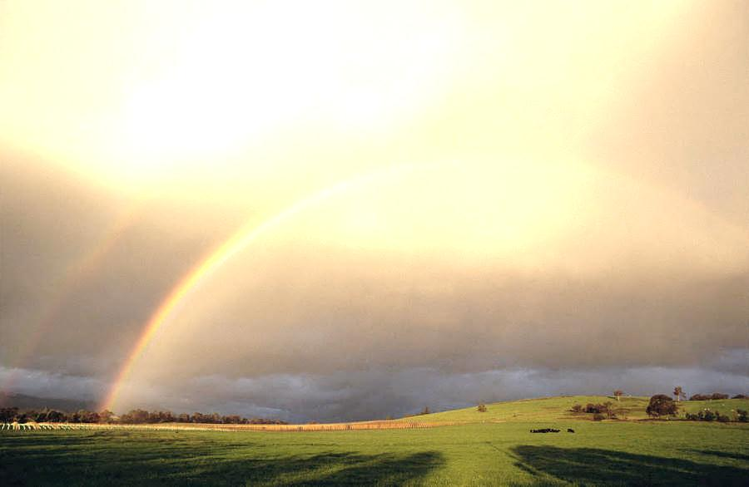

*Our Father, Who art in Heaven…*

**Prayers of ‘Commendation’**

‘Commendation’ prayers are normally used when someone is dying and may be very aware of this, and really *want* to be committed into God’s care.

They are also commonly used when someone is unaware or has recently died, and we seek to ‘commend’ them to God.

There are several forms of this type of prayer, some are more formal, some are less so. They are most often said by a chaplain or minister- but there is no reason why they cannot be said by someone else present if that is most appropriate.

One or two are included below:

**A prayer of commendation**

**(traditional)**

**Go forth on your journey, O Christian Soul, [*or name*]**

**in the name of God the Father who created you,**

**in the name of Jesus who died for you,**

**in the name of the Holy Spirit who strengthens you.**

**May your rest be in peace and your dwelling in the paradise of God.**

**May the heavens be open to you**

**May the angels rejoice with you**

**Receive your servant *N.* Lord into your kingdom. Amen.**

**or… A Franciscan Commendation**

***N*., may Christ give you rest in the land of the living and open for you the gates of Paradise;**

**may he receive you as a citizen of the Kingdom,**

**and grant you forgiveness of your sins:**

**for you were his friend.**

**Amen**

Blessings

**And Christ go behind you,**

**Christ above you**

**And Christ beneath you,**

**Christ beside you**

**And Christ within you,**

**Amen**

**May the blessing of God Almighty,**

**Father, Son and Holy Spirit,**

**Be with you now and for evermore,**

**And for evermore.**

**Amen**

**God be your comfort, your strength;**

**God be your hope and support;**

**God be your light and your way;**

**And may God: Creator, Redeemer and Sustainer,**

**Bless you and remain with you**

**Now and for ever.**

**Amen**

(From A New Zealand Prayer Book, adapted) Joyce Yarro

**Catholic prayers for the dead and dying**

Go forth, Christian soul, from this world  
in the name of God the almighty Father,  
who created you,  
in the name of Jesus Christ, Son of the living God,  
who suffered for you,  
in the name of the Holy Spirit,  
who was poured out upon you,  
go forth, faithful Christian,  
May you live in peace this day,  
may your home be with God in Zion,  
with Mary, the virgin Mother of God,  
with Joseph, and all the angels and saints.

**Hail Mary Full of Grace,  
the Lord is with thee.  
Blessed art thou among women,  
and blessed is the fruit of thy womb, Jesus.  
Holy Mary, Mother of God,  
pray for us sinners, now,  
and at the hour of our death. Amen.**

V/. Eternal rest grant unto him/her, O Lord.  
R/. And let perpetual light shine upon him/her.  
V/. May he/she rest in peace.  
R/. Amen.  
V/. May his/her soul and the souls of all the faithful departed,  
through the mercy of God,  
rest in peace.  
R/. Amen.

Prayers immediately after death

Saints of God, come to his/her aid!  
Come to meet him/her, Angels of the Lord!  
Receive his/her soul and present him/her to God the Most High.

May Christ, who called you, take you to Himself;  
may Angels lead you to Abraham’s side.

Give him/her eternal rest, O Lord,  
and may your light shine on him/her forever.

For more information or more copies, contact [:](mailto:simon.harrison2@nhs.net)

The Chaplaincy Team

Tel: 01202-448153 or 01202-442167